tenderflake pie crust
Yield: 6 individual pie shells (3 apple pies)

ingredients
- 5 1/2 cups all-purpose flour
- 2 teaspoons salt
- 1 lb tenderflake lard
- 1 egg, stirred slightly
- 1 tablespoon vinegar
- 7/8 cup cold water

Directions
- Stir the flour and salt together until evenly combined.
- Cut in the lard with a pastry blender or 2 knives until the shortening is in pea size pieces.
- In a measuring cup, combine the egg and vinegar.
- Add enough cold water to make one cup.
- Stir the liquid into the flour mixture, adding just enough to make the dough cling together.
- Stir the water in with a wooden spoon until mixed thoroughly, then gather the dough into a ball, and separate into 6 portions.
- Cover and refrigerate for one hour, you can chill overnight, covered, providing you leave it at room temp for 15 mins before rolling.
- Lightly flour surface and roll into circles, then pat the dough into pie pans, following pie recipes. Be careful not to stretch the dough.
- This is also a good dough for tarts, but you will want to roll the dough a little thicker than you would for pies.

PIE CRUST

Ingredients
- 750 mL all-purpose flour
- 7 mL salt
- 125 mL vegetable shortening
- 125 mL butter
- 125-130 mL ICE water

Instructions
- Spray a 9-inch pie plate and set aside.

- In a large bowl, combine the flour and the salt until mixed evenly. Cut in the shortening and butter with a pastry blender or two knives until the mixture resembles pea-sized pieces.

- Gradually add enough ice water to the mixture while mixing with a wooden spoon until a ball of dough is formed.

- Pour the dough onto a lightly floured sheet of plastic wrap and form into a disc. Lightly flour the top of the pie dough and place another sheet of plastic wrap on top. Rolling from the center outwards, roll until the dough is about a ⅛-inch thickness. Remove the top piece of plastic wrap, fold the dough over and lay across the pie plate and remove the bottom piece of plastic wrap. Press the pie dough lightly into the bottom and sides of the pie plate. Cover the pie plate with a piece of the plastic wrap and place in the freezer for at least 30 minutes to overnight.

- Fill the pie crust with pie filling and bake according to instructions for the pie recipe (SEE NEXT PAGE).

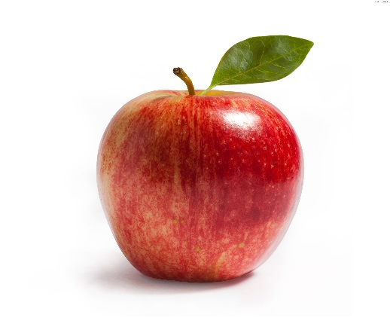
Prize-Winning Apple Pie

Ingredients:
125 mL unsalted butter
50 mL all-purpose flour
60 mL water
125 mL white sugar
125 mL brown sugar
7-8 Macintosh apples – peeled, cored, and sliced

Directions:
Preheat oven to 425 degrees F (220 degrees C). Melt the butter in a saucepan. Stir in flour to form a paste. Add water, white sugar and brown sugar, and bring to a boil. Reduce temperature and let simmer.
Place the bottom crust in your pan. Fill with apples, mounded slightly. Gently pour the sugar and butter liquid over the apples. Pour slowly so that it does not run off. Cover with top crust and decorate.
Bake 15 minutes in the preheated oven. Reduce the temperature to 350 degrees F (175 degrees C). Continue baking for 35 to 45 minutes, until apples are soft.
