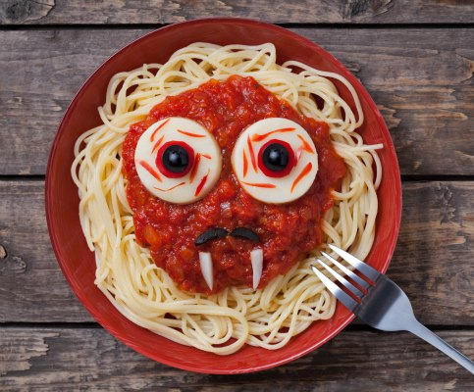
Brains, Guts, and Eyeballs
(or just good old-fashioned Spaghetti and Meatballs!)

Ingredients
For Pasta | For Meatballs | For Sauce
Spaghetti noodles  Salt, for pasta water | 200 g ground beef  1 egg, beaten  125 mL bread crumbs  50 mL parmesan cheese  Salt and pepper, to taste | 30 mL olive oil  2 mL crushed red pepper flakes  2 cloves garlic, minced  ½ onion, chopped finely  250 mL vegetable stock  800 mL crushed tomatoes  1-2 stems parsley, minced

Directions
- Preheat oven to 425 degrees F.
- Bring a large pot of water to a boil (#8). Add salt. Place a lid on the pot of water to ensure that the water boils faster. Once boiling, add pasta and cook to al dente (7-8 minutes). Use a colander to strain off the water. Put pasta back into the pot and set aside until meatballs and sauce are ready.
- Mix ground beef, egg, bread crumbs, cheese, garlic, salt and pepper. Roll the beef into 1/2 inch ping pong-sized meatballs, and place on tin-foil covered cookie sheet. Bake meatballs 10 to 12 minutes, until no longer pink. Check to make sure the meatballs are done using your food thermometer.
- Heat a medium skillet over moderate heat (#5). Add oil, crushed pepper, garlic and finely chopped onion. Sauté 5 to 7 minutes, until onion bits are soft and translucent. Add beef stock, crushed tomatoes, and herbs. Bring to a simmer, and cook for 10 minutes once bubbles start to form at the surface.
- At the stovetop, dish up individual plates of pasta. Cover pasta with tomato sauce, and place meatballs on top. Garnish with parsley. Serve hot.

