CAESAR BURGERS & OVEN-BAKED FRIES

250g ground beef
1 slice bacon, cooked and crumbled
1 egg
15 mL parmesan cheese
½ pkg. dry onion soup
1 clove garlic, minced
60 mL bread crumbs
50 mL creamy Caesar dressing
f.g. black pepper

-------------------------------------------------------------------------------------------------------------
Leaf lettuce Pickle, sliced (optional)
Swiss cheese (1 per person, optional)
Mayonnaise

- Cook bacon over medium (#4) heat in a large non-stick frying pan. Heat until crisp. Remove from pan and allow to cool. Crumble into small pieces.
- Mix all remaining ingredients in a large glass bowl. Divide into 4 or 5 portions and shape into patties using your hands.
- Fry the patties in the same pan over medium-low heat (#3-4), until browned. Meat should be cooked all the way through (no pink tinge). Flip only once or twice!
- To serve: cut crusty rolls in half horizontally and spread the top half with ~10 mL mayonnaise. Top with pickle and lettuce leaf. Place meat patty on opposite side of the crusty bun. Put cheese slice on top of patty, if desired. Serve fries on the same dinner plate.

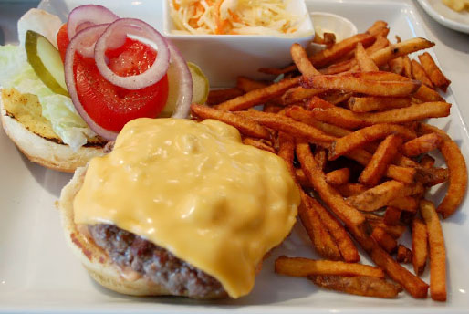

For Fries:

1 potato per person
15 mL canola oil (or olive oil)
10 mL seasoning salt

- Preheat the oven to 425*F. Line baking sheet with aluminum foil.
- Scrub potatoes well (use a brush!). Peeling is not necessary, as the skin adds fibre to your diet.
- Cut into wedges. The thinner the wedges, the faster they will cook!
- In a large bowl, soak the potato wedges in COLD water for 15-20 minutes. This will allow some of the starch to escape, resulting in crispier fries!
- Drain the potato wedges. Dry with paper towel. Toss wedges with oil and seasoning salt.
- Spread potatoes in a single layer on baking sheet.
- Bake 15 minutes. Turn potatoes using a metal spatula and bake for an additional 5-10 minutes.

