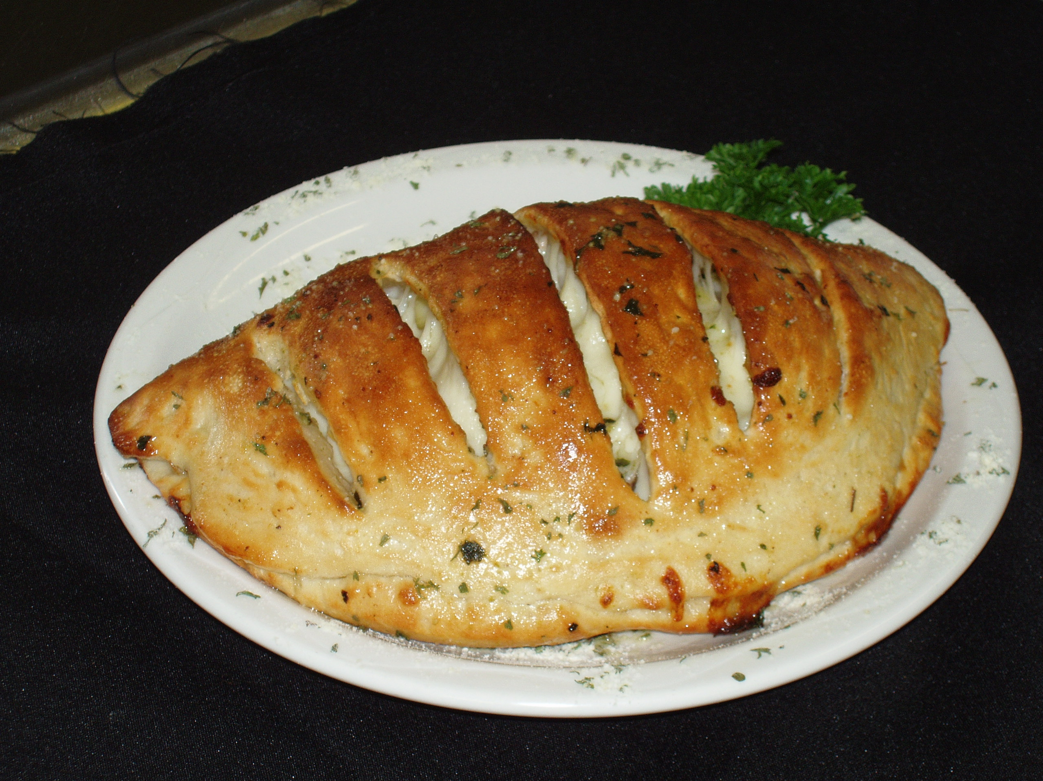
Calzones

2 ml garlic powder
spinach leaves (1/4 cup pp)
mushrooms, sliced (1 pp)
mozzarella cheese, grated
green pepper, diced
pepperoni OR ham
onion, diced

- Preheat the oven to 425°F.

- Divide the dough by the number of people in your kitchen.

- Roll dough out on counter, pat each piece into a 6”x6” inch circle.

- Sprinkle garlic powder evenly over rounds of dough. Top each with the toppings of your choice. Each student will make their own calzone.

- Bring opposite corners to centre, pinching points to seal. Use a fork to press the edges for a pretty, finished look.

- Place in the oven on a parchment-lined baking sheet and bake at 425°F for 12-15 minutes or until golden.

Crust

300ml flour 2.5ml salt
150ml WARM water 10ml fast rising yeast
10ml oil

- Mix all the dry ingredients for the crust in a large glass mixing bowl. Add the water and oil to the dry ingredients gradually, and mix together.

- Knead the dough 10-20 times, then let rise 10-15 minutes. Cover the dough in a damp dishtowel and do not disturb it while it rises. Go to Step #2 of the recipe above.

