Chicken Quesadillas (with Salsa)

- 1 skinless, boneless chicken breast, diced or shredded
- 1/4 packet fajita seasoning
- 1 teaspoon vegetable oil (5 mL)
- ½ green bell pepper, diced
- ½ red bell pepper, diced
- 1/4 onion, chopped
- ½ cup frozen corn (125 mL)
- 4 flour tortillas (1 per person)
- 100 grams shredded Monterey Jack cheese

- Preheat the broiler (LOW). Cover a baking sheet with aluminum foil.

- Toss the diced chicken with the fajita seasoning, then spread onto the baking sheet. Place under the broiler and cook for five minutes, until the chicken pieces are no longer pink in the center. TURN OFF BROILER.
- Once chicken is removed from oven, preheat oven to 350 degrees F.

- Heat the oil in a large saucepan over medium heat (#5-6). Stir in the green bell peppers, red bell peppers, onion, and chicken. Cook and stir until the vegetables have softened, about 7 minutes. Add frozen corn and cook for another 3 minutes.
- Divide the chicken and vegetable mixture into EQUAL portions (place each portion into a white soup bowl) so that each group member gets the same amount.

- Layer half of each tortilla with the chicken and vegetable mixture, then sprinkle with the cheese. Carefully fold the tortillas in half and using the same baking sheet, place all quesadillas in a row.
- Bake quesadillas in the oven until the cheeses have melted, about 10 minutes.

- Cut each tortilla into three pie-shaped wedges and serve with salsa.
***Tip: Using aluminum foil on the baking sheet can help to keep food moist, cook more evenly, and help to make clean-up easier!
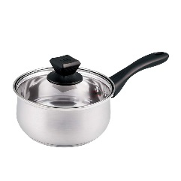
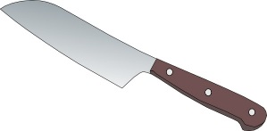
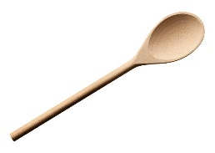
Homemade Salsa
200 mL canned diced tomatoes
¼ small onion, diced
25 mL green pepper, diced (reserved from quesadilla recipe)
5 mL garlic powder
25 mL tomato paste
15 mL vinegar
10 mL sugar
1 mL salt
2 mL dried red pepper flakes

- Put canned tomatoes, onion, green pepper, and garlic powder into a small pot and bring to a boil over med-high heat (#6). Stir occasionally with a wooden spoon to keep from burning.
- Reduce heat to LOW (#2-3) and add all (5) remaining ingredients.
- Continue to stir and simmer UNCOVERED for about 20 minutes (until thickened).

