Chicken Stir Fry with Quinoa
Yield: 4 servings
Ingredients:
80 mL (1/3 cup) soy sauce
30 mL (2 Tbsp) brown sugar
7 mL (1 ½ tsp) cornstarch
1 small piece ginger, minced
1 clove garlic, minced
1 mL (1/4 tsp) red pepper flakes
1.5 chicken breasts, thinly sliced into strips
20 mL (1 Tbsp + 1 tsp) vegetable oil
½ red pepper, cut into matchsticks
½ can sliced water chestnuts, drained
125 mL (1/2 cup) snap peas
1 carrot, sliced
½ onion, chopped
¼ broccoli crown, broken into floret

Directions:
- Combine soy sauce, brown sugar, and corn starch in a small glass bowl; whisk until smooth. Mix ginger, garlic, and red pepper flakes into the marinade.
- Spoon half of the marinade into a small baggie and coat the chicken. Set aside remaining marinade for later. Refrigerate the sealed baggie for at least 15 minutes to tenderize and bring flavour to the meat.
- Meanwhile, heat 10 mL vegetable oil in a large skillet over medium-high heat (#6). Sauté bell pepper, water chestnuts, snap peas, broccoli, carrots, and onion until just tender, about 5 minutes. Remove vegetables from skillet and place in a bowl, covering with tin foil to keep warm.
- Remove chicken from the baggie using tongs, and carefully place in the skillet. Dispose of the baggie and marinade. Cook and stir chicken with a spatula until chicken is cooked through.
- Return vegetables and leftover marinade (that you set aside in step 2) to the skillet. Simmer on medium-low (#4), cooking until vegetables are tender, about 5 to 7 minutes. Serve over quinoa.
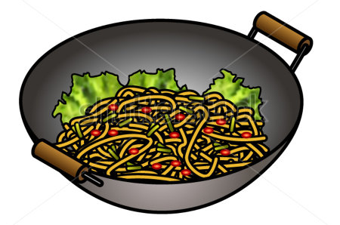

How To Cook Quinoa

Ingredients
1 cup (250 mL) uncooked quinoa (any variety — white or golden, red, or black)
2 cups (500 mL) water or broth
1/2 tsp (2 mL) salt

Directions
- Rinse the quinoa: Measure 1 cup of quinoa and place into a fine-mesh strainer. Rinse thoroughly with cool water for about 2 minutes. Rub and swish the quinoa with your hand while rinsing. Drain.
- Add liquid and bring to a boil: Stir in 2 cups of water (or broth) and 2 mL salt with a wooden spoon. Bring to a rolling boil.
- Lower heat (#3) and simmer: Cover the quinoa and cook for 15 minutes. Make sure to set a timer.
- Let stand, covered, for 5 minutes: Remove the pot from the element and let stand for 5 more minutes, covered with the lid. Don't peek! The steam helps to further cook the quinoa.
- Fluff and eat! Remove the lid — You should see tiny spirals (the germ) separating from and curling around the quinoa seeds. Fluff the quinoa gently with a fork, and serve. If any liquid remains in the bottom of the pan or if the quinoa is still a bit crunchy, return the pot to low heat and cook, covered, for another 5 minutes, until all the water has been absorbed.

