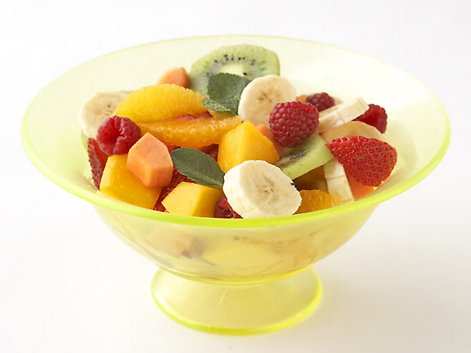
Fruit Salad

Ingredients:
1 cup strawberries, sliced
½ cup green or red grapes, sliced in half
¼ dragonfruit (OR 1 kiwifruit), cubed
1 orange, peeled and sectioned
½ banana, sliced
80 mL prepared orange juice
40 mL lemon juice
40 mL brown sugar, packed
Orange zest (from the peel of 1 orange)
2 mL vanilla extract

Directions:
- Bring orange juice, lemon juice, brown sugar, and orange zest to a boil in a saucepan over medium-high heat (#5). Once it is boiling, reduce heat to medium-low (#3), and simmer until slightly thickened, about 5 minutes. (Remember that sauces thicken when steam is allowed to escape). DO NOT USE A LID!
- Remove from heat, and stir in vanilla extract. Pour into a small bowl and bring to the demo table so that Mrs. Chase can put it in the fridge to cool.
- Layer the fruit in a glass bowl. Pour the cooled sauce over the fruit. Stir carefully to coat the fruit. Serve in ice cream cups. Top with a cherry.

