GENERAL BYNG WAFFLES

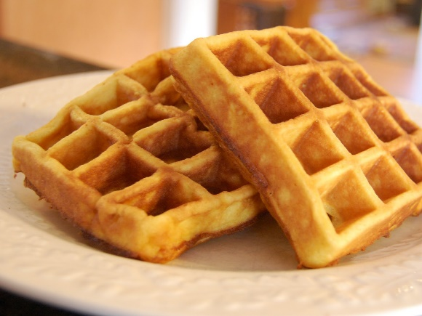
Sift together in LARGE glass bowl:
375 mL flour
30 mL baking powder
25 mL sugar
Whisk together in MEDIUM glass bowl:
3 eggs (or egg alternative)
75 mL oil
350 mL milk
1. Place waffle iron on dry, level surface. Adjust thermostat to the black mark indicated by your teacher. Plug in the cord. Once plugged in the RED light will go on.
- Keep the waffle maker closed while it is pre-heating. When the correct temperature has been reached, the GREEN indicator light will go on.
- Pour liquid ingredients into dry ingredients and stir.
- Use 125 mL (1/2 cup) measure to SLOWLY pour batter onto the centre of bottom cooking plate. Use a heat proof spatula to distribute the batter evenly over the grids. DO NOT USE A METAL UTENSIL!
- Close the lid. The RED light will turn on. Your waffle should be ready when the GREEN light comes on again The waffle is done when there is no more steam escaping from the waffle maker.
- To remove the waffle, lift gently after loosening the edges with a heatproof spatula. Serve with syrup and a side of fruit salad.

Unplug the unit and allow to cool down. Leave the lid open.
Wipe the waffle iron with a DRY cloth or paper towel. Polish the outside.
To prevent stains, or build-up of oil, use a DAMP cloth to clean the inside plates.
NEVER USE ABRASIVE CLEANSERS OR SCRUBBING PADS AS THIS
WILL DESTROY THE NON-STICK SURFACE!

