Gluten-Free Lava Cakes

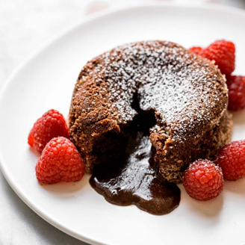
Ingredients
- 3 oz. bittersweet chocolate, chopped
- ¼ cup (60 mL) unsalted butter
- 1 large egg, room temperature
- 1 egg yolk, room temperature
- 1/4 cup (60 mL) granulated sugar
- Pinch of salt
- 2 Tbsp (30 mL) gluten-free flour

Instructions
- Preheat oven to 400 degrees F. Grease 2 ramekins or custard cups with margarine, using wax paper. Lightly dust/coat with cocoa powder and shake off excess. Set aside.
- Melt the butter in a microwave-safe bowl. Make sure to cover the bowl so that the butter does not spatter. Whisk in the chocolate until melted and incorporated evenly.
- Add the egg, egg yolk, granulated sugar, and salt to a medium bowl. Use a hand mixer to beat on medium speed until light in color and slightly thickened.
- Gradually add chocolate mixture to egg mixture and beat to combine.
- Add the gluten-free flour and use a spatula to fold into the chocolate mixture until just combined.
- Transfer the batter equally among the two prepared ramekins. Bake at 400 degrees F for 12-14 minutes. When done, the edges will be set and the middle will be soft and jiggly.
- When done, cool in the ramekins for 1 minute. Then invert onto a plate and let sit for 10-15 seconds before removing the ramekin.
- Serve immediately with vanilla ice cream and/or raspberry sauce.

