GREEK QUINOA SALAD

INGREDIENTS
- 750 mL (3 cups) chicken stock
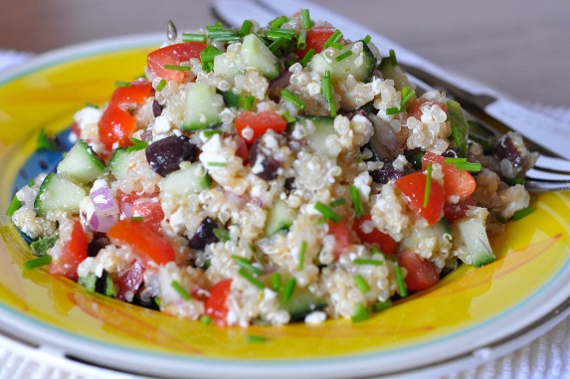
- 375 mL (1 ½ cups) quinoa
- 1 pepper, diced
- 1 cucumber, diced
- ¹⁄₃ cup black olives, sliced
- ¹⁄₄ red onion, diced
For DRESSING:
- 1 clove garlic, minced
- 90 mL lemon juice
- 45 mL olive oil
- 3 mL basil
- 3 mL oregano
- 1 mL ground black pepper

DIRECTIONS
- In a saucepan, bring chicken stock and quinoa to a boil (#8).
- Reduce heat to medium low (#4) and cover.
- Cook 15 minutes, until liquid is absorbed. Stir occasionally so that quinoa does not stick to bottom of pan. Quinoa is cooked when a white ring forms around the edge of the grain.
- Fluff with a fork, transfer to a large bowl and cool in the fridge.
- Stir veggies into cooled quinoa.
- Whisk together dressing ingredients.
- Pour over quinoa mixture and toss.

