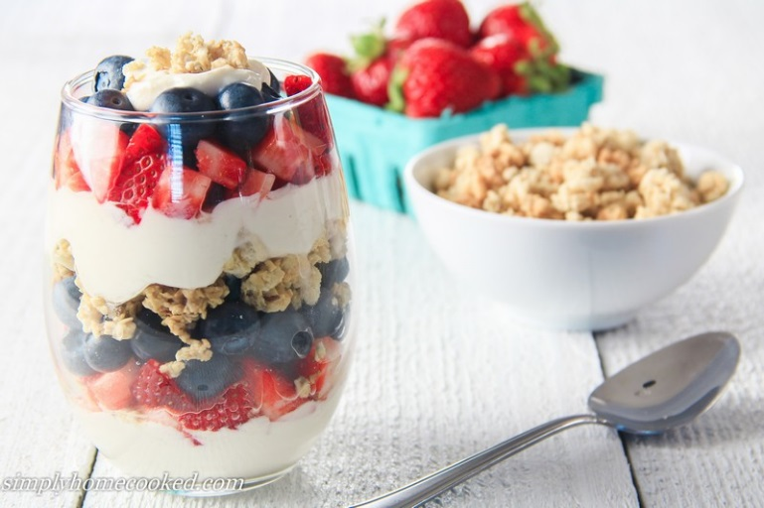
Greek Yogurt Parfaits with Homemade Granola
For Granola:
- 4 cups rolled oats
- 1 mL salt
- 15 mL ground cinnamon
- 30 mL ground flax seeds (optional)
- 250 mL almonds (optional)
- 80 mL oil
- 160 mL corn syrup
- 5 mL vanilla extract
- Heat oven to 300 degrees Fahrenheit.
- Combine oats, nuts (optional), salt, cinnamon and flax (optional) in a large bowl and set aside.
- Combine oil, corn syrup, and vanilla in a separate bowl.
- Mix wet ingredients into dry - you may need to use your hands to make sure the oats are evenly coated.
- Then spread the mixture onto two cookie sheets lined with parchment.
- Bake 10 minutes. Then remove from oven and stir.
- Bake an additional 10 minutes or until slightly golden.
- Remove from oven and allow to cool completely before serving.
For Parfaits: (per person)
- ½ cup honey Greek yogurt
- ½ cup berries (fresh or frozen)
- ¼ cup granola
- Rinse and then pat the berries with paper towel until dry. Cut berries into small pieces.
- Layer yogurt, berries and granola in an ice cream dish or tall glass. Start with Greek yogurt, then the berries, followed by granola sprinkled on top. Serve with a spoon.

