Homemade Caesar Salad

Yield: ~10 starter salads

Ingredients
- 2 small garlic cloves, minced
- ½ lemon
- 5 mL Dijon mustard
- 5 mL Worcestershire sauce
- 250 mL mayonnaise
- 125 mL parmesan cheese
- 1 mL salt
- 1 mL black pepper
- 2 heads romaine lettuce, washed and torn into bite-sized pieces

Instructions
- In a medium bowl, whisk together the garlic, Dijon mustard and Worcestershire sauce. Add the mayonnaise, parmesan cheese, salt and pepper and whisk until well combined.
- After washing and ripping the lettuce, toss the salad with the dressing.
- Squeeze fresh lemon juice over the salad.

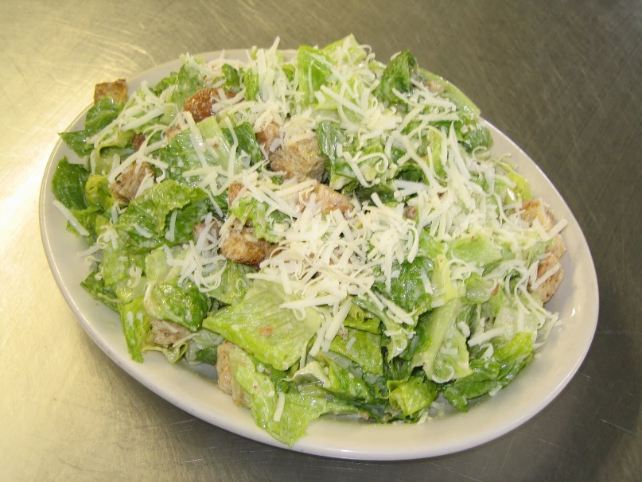

Homemade Caesar Salad

Yield: ~4 starter salads

Ingredients
- 1/2 small garlic clove, minced
- 1/4 lemon
- 1 mL Dijon mustard
- 1 mL Worcestershire sauce
- 80 mL mayonnaise
- 40 mL parmesan cheese
- 1 mL salt
- 1 mL black pepper
- 1 head romaine lettuce, washed and torn into bite-sized pieces

Instructions
- In a medium bowl, whisk together the garlic, Dijon mustard and Worcestershire sauce. Add the mayonnaise, parmesan cheese, salt and pepper and whisk until well combined.
- After washing and ripping the lettuce, toss the salad with the dressing.
- Squeeze fresh lemon juice over the salad.

