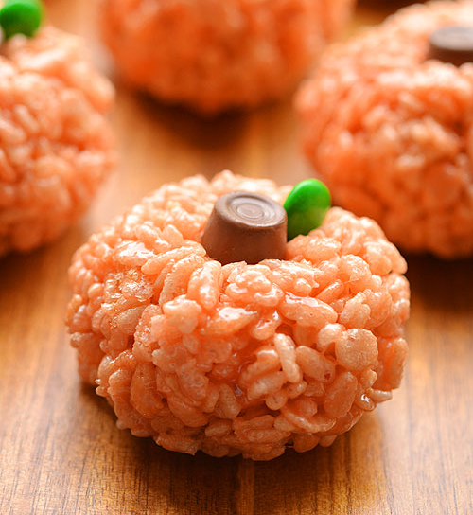
Rice Krispie Pumpkin Treats

Ingredients
- 40 ml (2 Tbsp + 2 tsp) butter
- 25 large marshmallows
- 4 cups (1 L) Rice Krispies
- Red & Yellow Liquid Food Coloring
- Mini Rolos (or other chocolate to represent the stems)
- Green M&M's (or other green candy to represent the leaves)
- Cooking oil

Directions
- In a large pot, melt the butter over low heat (#3).
- Add the marshmallows and stir until completely melted and combined with the butter.
- Remove from heat. Add 8 drops of yellow food colouring and stir. Then, add 2 red food colouring one drop at a time, mixing as you go. Mix well until food colouring is evenly distributed.
- Add the Rice Krispies and stir to combine.
- Coat your hands with a generous amount of cooking oil, and roll the Rice Krispie mixture into small balls. Set on parchment paper.
- While the balls are still warm, gently press a chocolate into the top of each pumpkin for the stem, and add a green candy beside it, as the leaf. (Tip: If the pumpkins cool before you're finished, use the end of an apple corer to make a small indent in the top for the chocolate to sit in.)
- Allow to cool until firm. Enjoy!

