Sushi
Sticky (Sushi) Rice 375ml (1 ½ cups) Bamboo mats 2
Water 560 ml (2 ¼ cups) Nori (Seaweed Sheets) 4
Rice Vinegar 60ml (¼ cup) Pickled Ginger
Sugar 15ml (1 Tbsp) Soy Sauce
Salt 5ml (1 tsp) Sriracha Sauce

Rice  - Rinse the sticky rice under cold water in a fine sieve until liquid underneath runs clear, not cloudy.  - Combine sticky rice and water in a large pot and bring to a boil on high heat (8), uncovered.  - Once water begins to boil, reduce heat to LOW (2) and cover pot with lid. Let simmer for 12 MINS or until water is boiled away and the rice is soft. Taste the rice before removing from heat. | Vinegar  - Combine vinegar, sugar, and salt in a small pot and put on medium heat (5).  - Stir constantly until salt and sugar dissolve and then remove from heat.
Making the sushi rice
- Put the rice in a large plastic mixing bowl. Do not scrape the stuck-on rice at the bottom of the pot, as it will be too cooked to use.
- Pour the vinegar mixture over the rice.
- Using a rubber spatula, cut and fold the rice to mix in the vinegar evenly.
- Cover the rice with a damp towel, and allow to cool.

Fillings
- Clean your vegetables well.
- Julienne (cut into thin matchsticks) your vegetables and other fillings.
- Set aside until rice is ready.

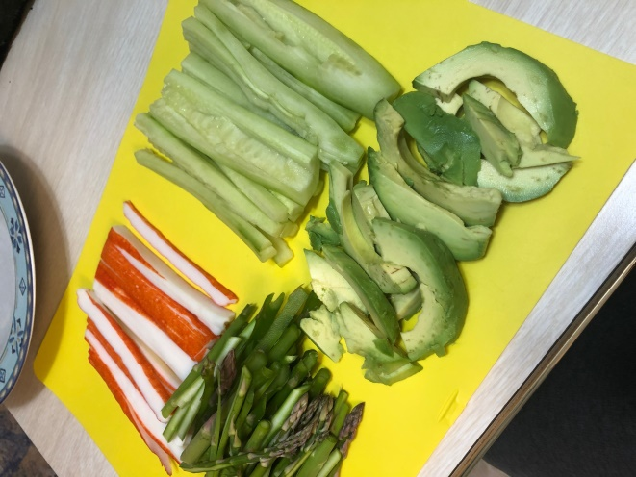
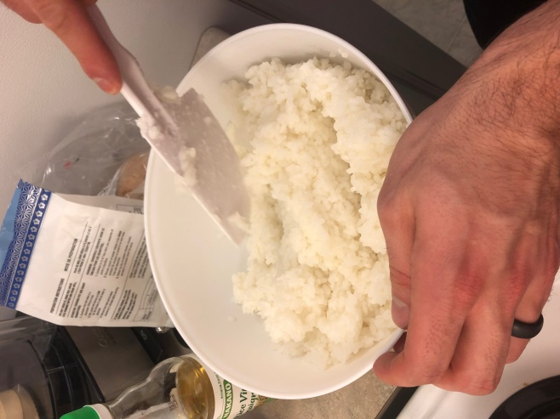

Rolling your sushi
- Place one Nori on a bamboo mat, with the shiny side down.
- With wet fingertips, grab a fistful of rice, and begin to cover the Nori with rice. Leave a ¾ inch (2 cm) space at the top of your Nori. Wet your fingertips if the rice starts to stick. Do not pat the rice down.
- Place your fillings down the centre.
- Grasp the bamboo mat with your thumbs, holding the filling in place with your fingers.
- Begin to tightly roll the mat over the filling, squeezing to compress.
- Once the edge is sealed, cut the roll into 8 slices. Wet the knife with cold water in between each cut to prevent sticking.
- Serve with ginger, soy sauce, or sriracha sauce.

